**Assignment 5.3**

**Problem Statement:**

**Implement the use case present in below blog link and share the complete steps along with screenshot(s) from your end.**

**NOTE: You must submit a word file containing steps and screenshots.**

[**https://acadgild.com/blog/pig-use-case-pokemon-data-analysis/**](https://acadgild.com/blog/pig-use-case-pokemon-data-analysis/)

**Loading Data**

Load_Data = LOAD 'Pokemon.csv' USING PigStorage(',')

AS(Sno:int,Name:chararray,Type1:chararray,Type2:chararray,

Total:int,HP:int,Attack:int,Defense:int,SpAtk:int,SpDef:int,Speed:int);





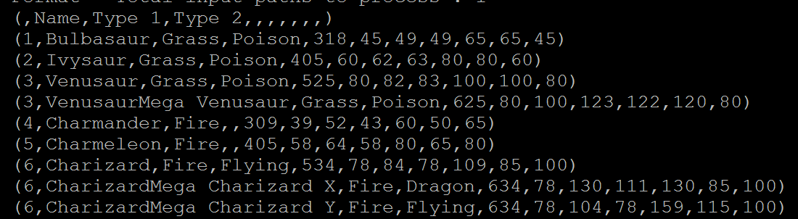



***Ques 1: Find the list of players that have been selected in the qualifying round (DEFENCE>55).***

selected_list = FILTER Load_Data BY Defense>55;

dump;



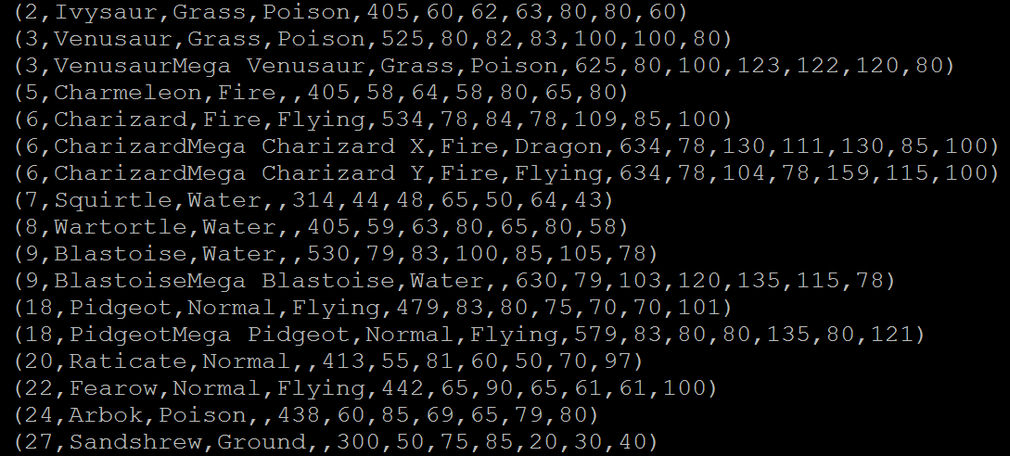

The dataset is filtered, and hence out of all the 800 Pokémons, only 544 are eligible to take part in the tournament.

***Ques 2: State the number of players taking part in the competition after getting selected in the qualifying round.***

gourp_selcted_list = Group selected_list All;

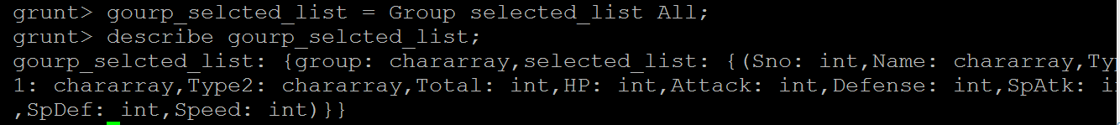

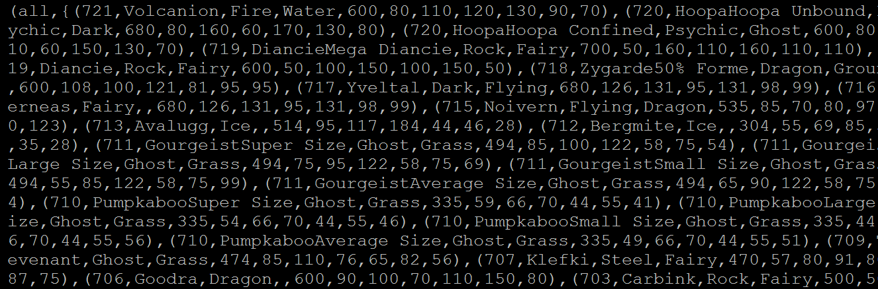

count_selcted_list = foreach gourp_selcted_list GENERATE COUNT(selected_list);



dump;





***Ques 3: Using random() generate random numbers for each Pokémon on the selected list.***

random_include1 = foreach selected_list GENERATE RANDOM(),

Name,Type1,Type2,Total,HP,Attack,Defense,SpAtk,SpDef,Speed;

dump;



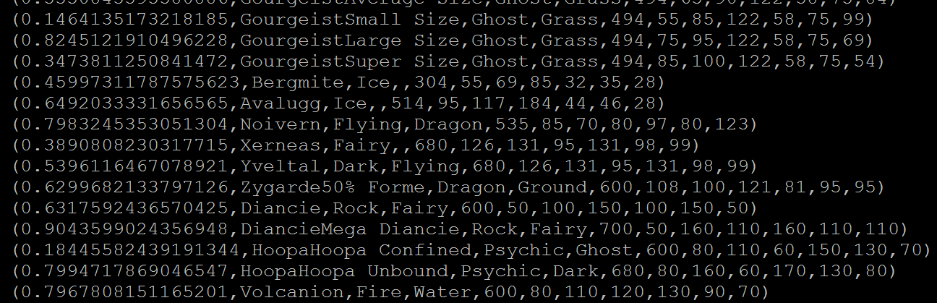



***Ques 4: Arrange the new list in a descending order according to a column randomly.***

This will give us consequently a layer arranged to pick the random list which 1st player will choose.

random1_desending = ORDER random_include1 BY $0 DESC;

dump;



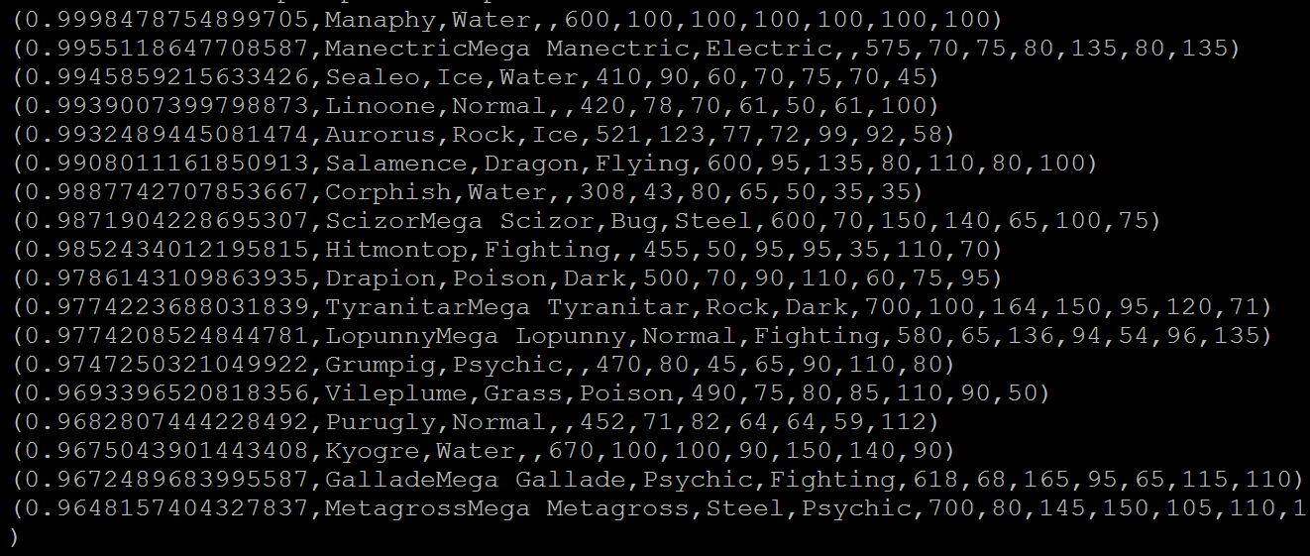

***Ques 5: Now on a new relation again associate random numbers for each Pokémon and arrange in descending order according to column random.***

random_include2 = foreach selected_list

GENERATE RANDOM(),Name,Type1,Type2,Total,HP,

Attack,Defense,SpAtk,SpDef,Speed;

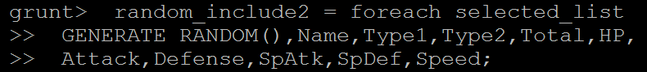

dump;



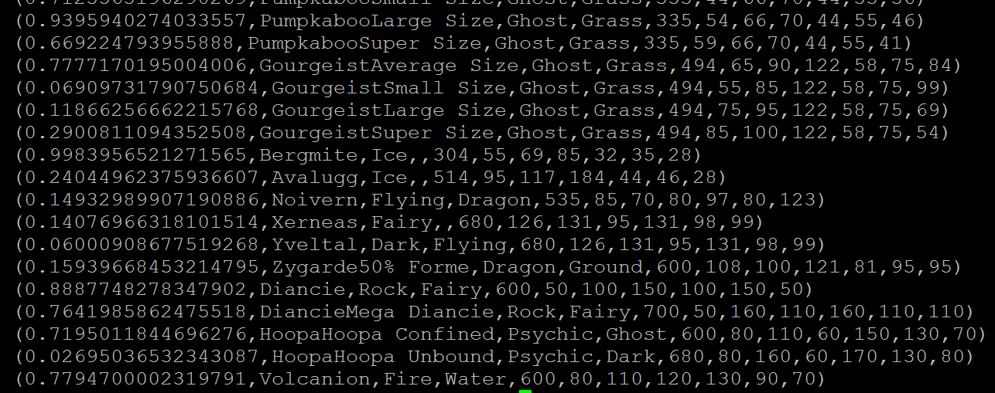

random2_desending = ORDER random_include2 BY $0 DESC;



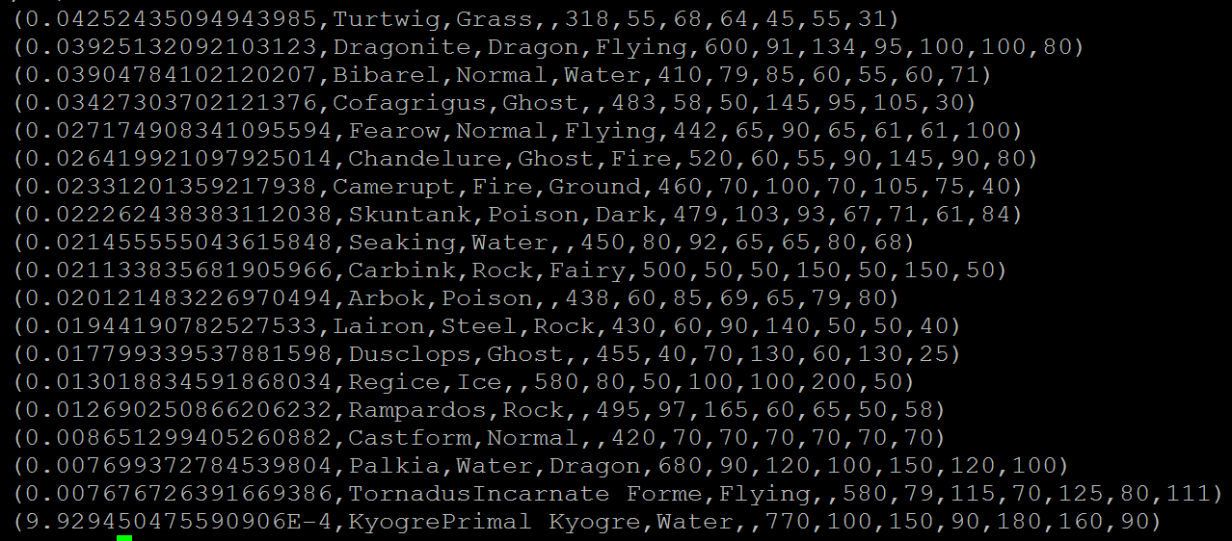

***Ques: From the two different descending lists of random Pokémons, select the top 5 Pokémons for 2 different players.***

**limit_data_random1_desending = LIMIT random1_desending 5 ;**



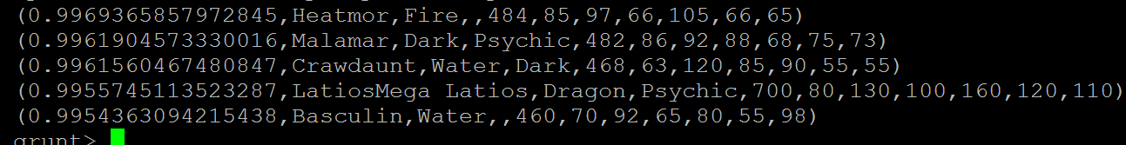

**limit_data_random2_desending = LIMIT random2_desending 5 ;**



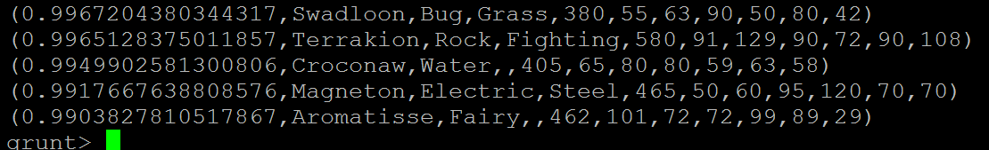

***Ques: Store the data on a local drive to announce for the final match. By the name player1 and player2 (only show the NAME and HP).***

***filter_only_name1 = foreach limit_data_random1_desending Generate ($1,HP);***



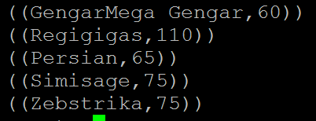

**filter_only_name2 = foreach limit_data_random2_desending Generate ($1,HP);**



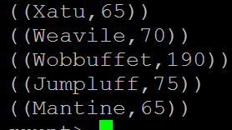

 let’s store this result in our local system



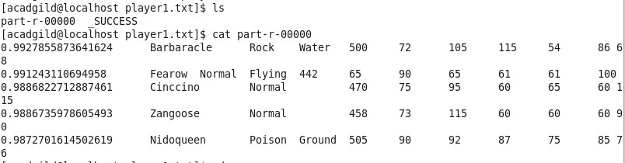



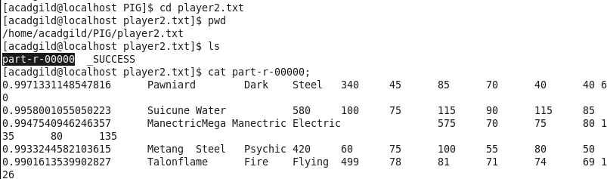

As a result, the Pokémons for both players got selected . This player will be fighting consequently in the finals with their respective Pokémons assigned.